Rotary Club of Kathmandu Mid-Town
Breakfast Chatter




11 November 2011 The Weekly Bulletin of Rotary Club of Kathmandu Mid-Town Bc-11.11/011-12

District: 3292 Web: www.rotarymidtown.org.np Club Id : 26776

NOVEMBER IS THE ROTARY FOUNDATION MONTH
The mission of The Rotary Foundation is to enable Rotarians to advance world understanding, goodwill, and peace through the improvement of health, the support of education, and the alleviation of poverty. Specifically, the RI Board and the Trustees are committed to achieving the goals of eradicating polio through the completion of the Polio-Plus program; emphasizing and strengthening educational and cultural programs, which enhance goodwill and understanding; making grants that fulfill humanitarian needs in all areas of the world; and expanding programs intended to strengthen peaceful relations among people.

Friday, 4 November:
Rtn Ronald Aumuller, President of RC Landshut Germany was our Guest speaker for the day. Dr Aumuller along with a team of Rotarians from Germany visited our club and provided information on various projects the RC Landshut supported over a period of 18 years since 1992. The projects were implemented in Nepal in association with various agencies. Rtn Aumuller informed that Nepal figured top in terms of the Club expenditure on community service projects outside Germany.

Weekly Meetings and Programs :
Date | Program/Speaker | Program/Topics of Presentation
11 November 2011 | Mr Pasi Koistinen, CEO Ncell | Ncell Strategy and Outcome 2009-2011
18 November 2011 | Charter Nite | Charter Nite
25 November 2011 | 2nd Club Assembly | 2nd Club Assembly
2 December 2011 | Dr Donald Sammut | Plastic/ Hand Surgery Experiences

11 November, Friday:
Mr. Pasi Koistinen, CEO of NCell, will be talking on Ncell strategy and how successful has it been over the year 2009 through 2011.
Let’s us see what has been the Ncell strategy in Nepal over the years. Don’t miss this opportunity!

Computer Hand-over:
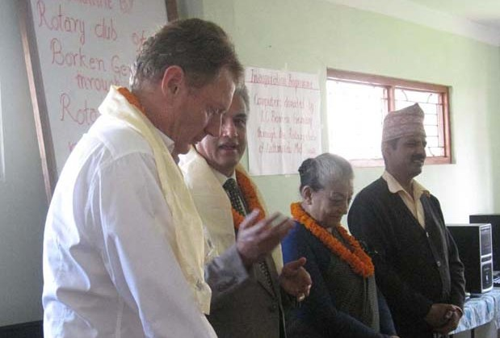

RC Kathmandu Mid-Town and RC Borken Germany jointly handed over 7 sets of Computer and one UPS to Shree Sitaram Higher Secondary School, Ramkot on 24 October 2011.

In the photo, President Som is seen thanking Rtn Remy for the support after the hand over.

Rtn Remy, on behalf of RC Borken, expressed his happiness to be a part of the program while he has been in the town, and hoped the computers would be beneficial for the students.

School Principal Jagannath Bhattarai thanked RC Kathmandu Mid-Town and RC Borken for the help.
Rtn Remy, President Som, PP Ambica and School Principal Jagannath

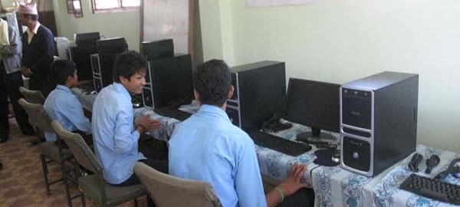
After hand over students on computer.

Interact Week Celebration:
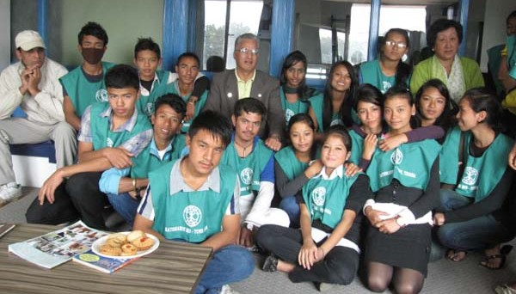
President Som and PP Lekha attended Interact Week Celebration organized by
Interact Club of Kathmandu Mid-Town, Thaiba recently. President Som and PP Lekha in the photo with Interacts.

RI Convention 2012, Bangkok:
Register now for the 2012 RI Convention in Bangkok, Thailand, 6-9 May, and enjoy an unforgettable experience in the Land of a Thousand Smiles!
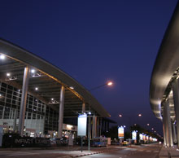
RI registration services require three to four weeks to process registration forms.
Make registration on time i.e. before 15 Nov 2011.
Registration fee for convention is US $ 160 (valid till 15 Nov 2011) + courier charges Rs 500 + bank commission Rs 250 + administration charge Rs 150 at NIC Bank.
For registration, please deposit Rs 13,860 at NIC Bank in HS a/c # 019-77635, account holder Rtn Chandra Kumar Golchha; the amount worked out at exchange rate of US$ 1 = Rs 81; any variance at the time of actual payment in US$ will be adjusted by the way of refund or request for further deposit.
NIC Bank will send US$ draft to RI.
Rotarians interested in attending pre-convention programs such as Peace Symposium, Paul Harris Fellow Celebration, President Recognition Luncheon, Host Hospitality Event etc. Respected Rotarians, will have to pay extra as listed in the registration form.
For registration form / host even ticket order form or for any other information, please get in touch with Rtn Chandra K Golchha, Chairperson, District RI Convention Promotion Committee 2012 at telephone # 4445732 and 4445733.

Membership Satisfaction Questionnaire:
Please remember that the deadline for sending your Feedback on Club performance is
15 Nov 2011
Complete Membership Satisfaction Questionnaire and email it to Rtn Lisa, Chair of Membership Committee, at lisa@mos.com.np within the deadline.

RLI Training
If you are looking forward to being Rotary leader in future, here is an opportunity for you!
Rotary Leadership Institute is conducting the first RLI Training for future leaders. The training is scheduled to be held in Kathmandu on 12 thru 14 November 2011.
The training is divided into 3 parts - part I, part II and part III : without completing part I training, one will not be eligible for participating in part II and similarly, one must complete part II before being eligible for part III training.
Training program is scheduled as follows: Part I on 12 Nov, Part II on 13 and Part III on 14 November.
Participants: 2 Rotarians from each Club, preferably Club leaders, other than President/PP, on first come first basis
Venue: Adarsha Kanya Niketan School, Mangalbazar, Patan Durbarsquare (opposite Krishna Mandir, behind dhungedhara)
Registration deadline: 5:00 pm, 11 November 2011
Registration fee: Rs.800 for 1 day, 1,400 for 2 days, and 2,000 for 3 days (inclusive of breakfast, lunch and tea)
Registration limit: 30 participants
Contact President Som for nomination to the training.

Walk for Disability Awareness on Saturday, 3 Dec 2011:
The Nepal Orthopaedic Hospital is organizing a ‘walk for disability awareness’ program on Saturday,
3 Dec 011 morning to coincide with the 20th International Day of Disabled Persons.
The objective of the program is to raise awareness about disability and also to raise some funds that will go for treating poor patients coming to the hospital.
The event will start at 7:00 AM from Basantapur Durbarsquare to around Kathmandu via Ason, Durbarmarg, Bhadrakali, Newroad gate and back to Basanatapur.
Participants will each get one T-shirt with appropriate logos and also breakfast.
The program is considered as a District event. Participation is by purchasing ticket costing Rs 1,000 per person or by donating fund for the event.

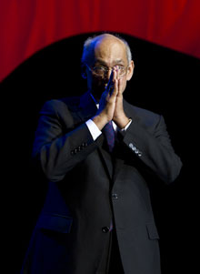
In life, everything is a choice. We can choose to close our eyes to the needs of others, to keep what we have for ourselves, to declare the problems of others to be theirs alone. Or
we can choose to look past distance, past color, past language and dress and culture, and
see that people everywhere are just like us – and then refuse to walk away.
RI President Kalyan Banerjee

Lighter side:
Do you find these word meanings in dictionary ?
Secret : Something you tell to one person at a time;
Tomorrow : One of the greatest labor saving devices of today;
Skeleton : A bunch of bones with the person scraped off;
Inflation : Cutting money in half without damaging the paper;
Committee : A body that keeps minutes and wastes hours;
Chickens : The only animals you eat before they are born and after they are dead.

Please send project/activity information, suggestions and photos etc to :
BC Editor: RR Shrestha email: rryes@wlink.com.np

11 November 2011 The Weekly Bulletin of Rotary Club of Kathmandu Mid-Town bc-11.11/011-12

